43.5: a) 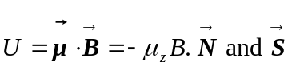 point in the same direction for a proton. So if the spin magnetic moment of the proton is parallel to the magnetic field, 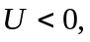and if they are antiparallel, 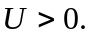 So the parallel case has lower energy.
The frequency of an emitted photon has a transition of the protons between the two states given by:
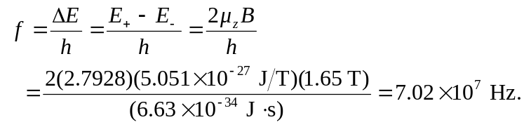
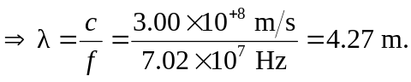 This is a radio wave.
b) For electrons, the negative charge means that the argument from part (a) leads to the 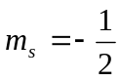 state (antiparallel) having the lowest energy, since 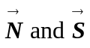point in opposite directions. So an emitted photon in a transition from one state to the other has a frequency
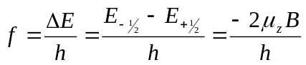
But from Eq. (41.22),
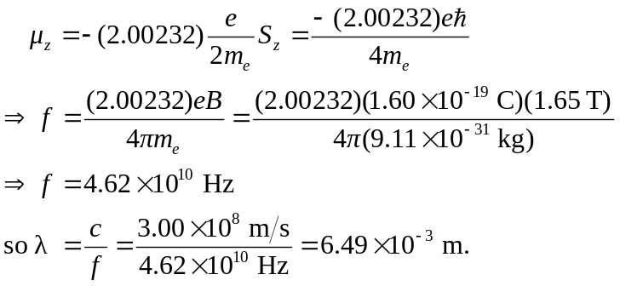
This is a microwave.

